Terraform Task -01
1). Install Terraform on your PC

Step 1. Download Terraform
Go to the official HashiCorp Terraform download page:
Terraform Downloads
Download the Windows AMD64 ZIP file.
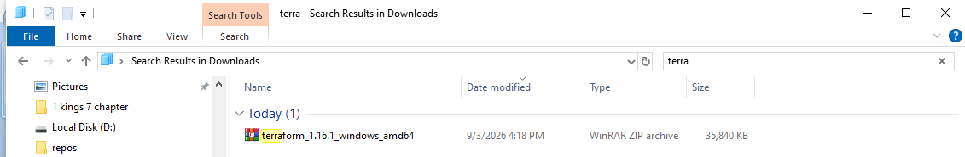

Step 2. Extract the ZIP
Extract it somewhere such as:
C:\terraform
You should have:
C:\terraform\terraform.exe

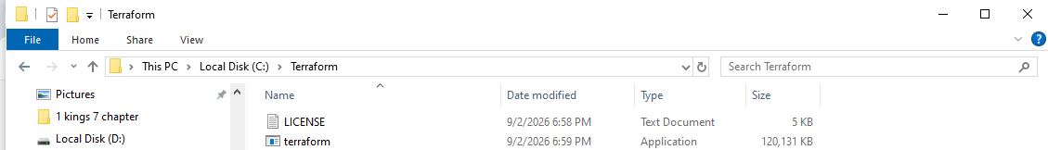

Step 3. Add Terraform to PATH
- Press Windows key
- Search for Environment Variables
- Select Edit the system environment variables
- Click Environment Variables
- Under System variables, select Path
- Click Edit
- Click New
- Add:
C:\terraform
- Click OK on all windows.
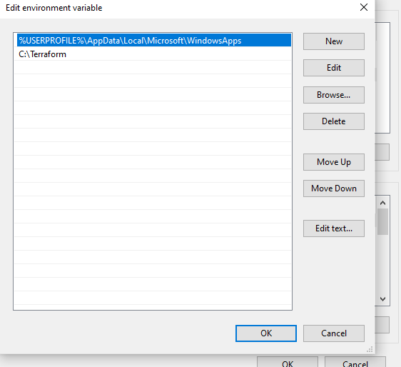

Step 4. Verify installation
Open a new PowerShell window and run: terraform version
You should see something similar to:
Terraform v1.x.x
on windows_amd64
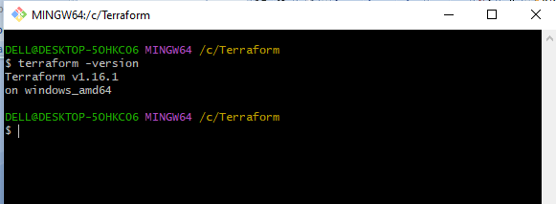

Step 5. Test Terraform
Run: terraform -help
If the help output appears, Terraform is installed correctly.
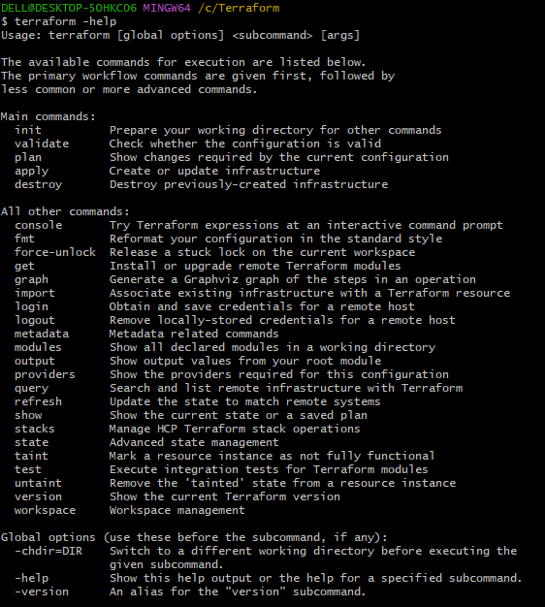
2). Execute all the templates shown in video.

Step 1. Open VS Code
Open Visual Studio Code.

Step 2. Create a project folder
In VS Code:
File → Open Folder → New Folder
Create: terraform-project
Then click Select Folder.
Your VS Code Explorer should show: terraform-project
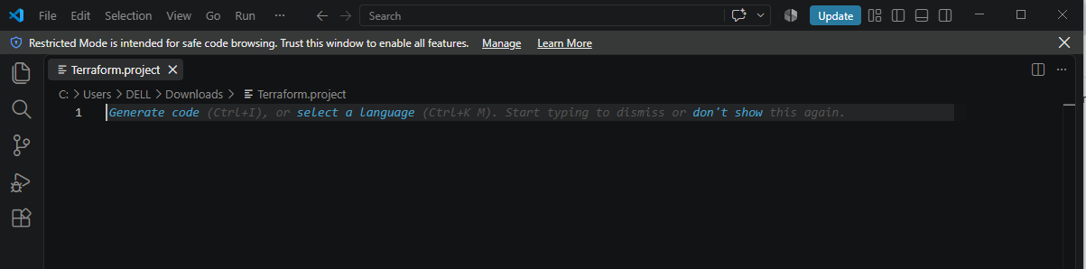

Step 3. Create main.tf
In the Explorer on the left:
Right-click terraform-project → New File
Name it: main.tf
Write code inside.
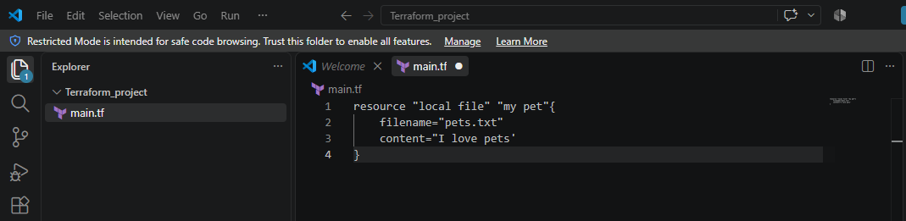

Step 4. Open the VS Code terminal
Go to: Terminal → New Terminal
You should see something like: PS C:\Users\YourName\terraform-project>
Check Terraform: terraform version
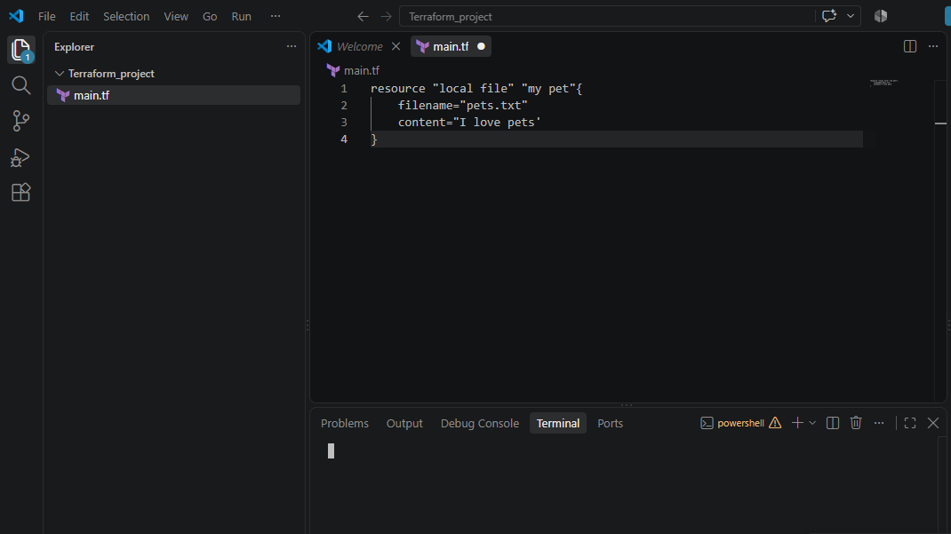

Step 5. Initialize Terraform
Run: terraform init
You should get: Terraform has been successfully initialized!
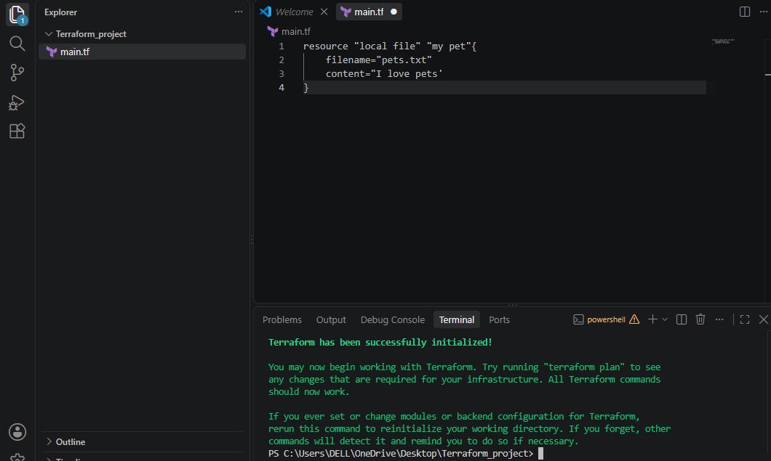

Step 6. Validate your code
terraform validate
Expected: Success! The configuration is valid.
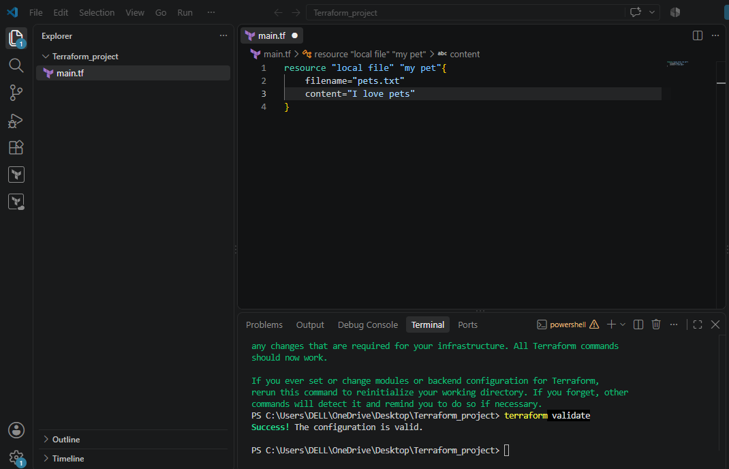

Step 7. Create an execution plan and apply
terraform plan
Terraform will show what it is going to create.
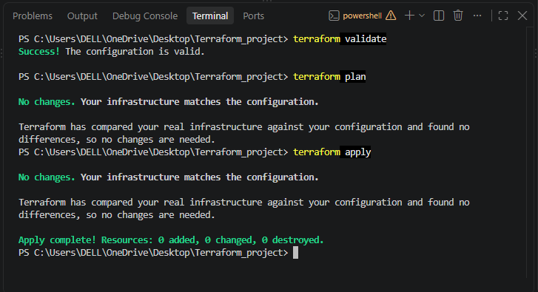
Changed the content and executed terraform plan:
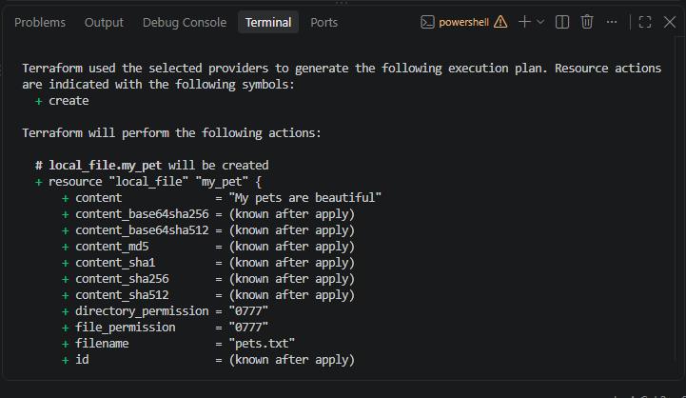
After executing Terraform apply, Terraform will ask:
Do you want to perform these actions?
Enter a value:
Type: yes
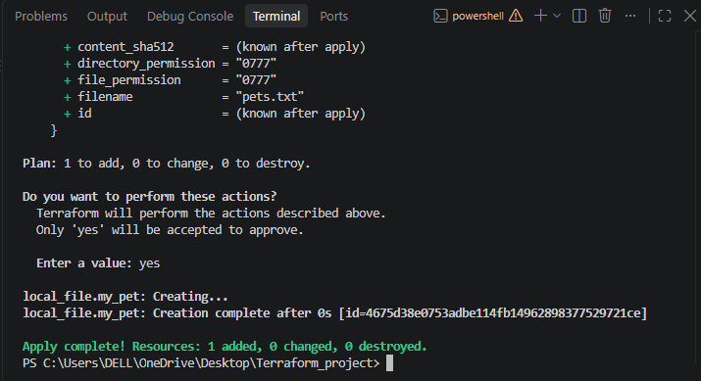
Use terraform destroy to deleted the file that is created:
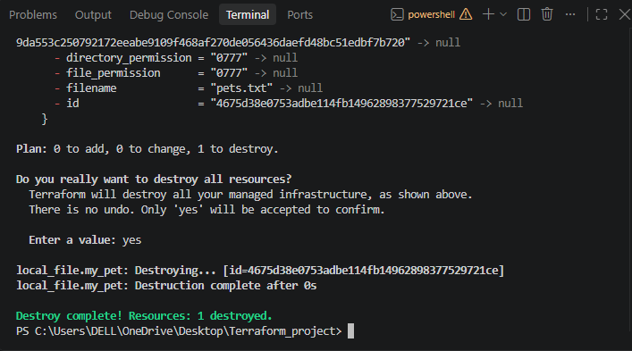
3). Note down below points, Terraform Init Terraform Plan Terraform Apply Terraform Provider.
1. Terraform Init
terraform init is a Terraform command used to initialize a working directory by downloading the required providers and modules and preparing the project for other Terraform commands.
Terraform will:
- Initialize the project
- Download the required providers from the Terraform Registry
- Set up the .terraform directory
- Create/update .terraform.lock.hcl
- Prepare the project for terraform plan and terraform apply

Example
Suppose your main.tf contains:
terraform {
required_providers {
aws = {
source = "hashicorp/aws"
version = "~> 6.0"
}
}
}

2. Terraform Plan
terraform plan is a Terraform command that creates an execution plan showing what changes Terraform will make to the infrastructure before actually making those changes.
Example:
terraform plan
It shows whether Terraform will:
- Create resources
- Update resources
- Destroy resources
Important: terraform plan does not make any changes to your infrastructure. It only shows what Terraform intends to do.

3. Terraform Apply
terraform apply is a Terraform command used to execute the changes defined in the Terraform configuration and create, update, or delete infrastructure resources.
Example:
terraform apply
It actually makes changes to your infrastructure, unlike terraform plan, which only shows the proposed changes.
Simple flow:
terraform plan → See what will happen
↓
terraform apply → Make the changes
4. Terraform Provider
A Terraform Provider is a plugin that allows Terraform to communicate with and manage resources on external platforms such as AWS, Azure, Google Cloud, Kubernetes, or GitHub.
For example, the AWS Provider allows Terraform to create and manage AWS resources such as:
- EC2
- VPC
- S3
- IAM
- RDS
Example:
provider "aws" {
region = "ap-south-1"
}

4). Integrate a sample Terraform template in Jenkins.

Step 1: Create a Terraform project and Create the Terraform template
On your PC, open VS Code.
Create a folder:
terraform-jenkins
Inside it create:
terraform-jenkins/
└── main.tf
Open main.tf and add code
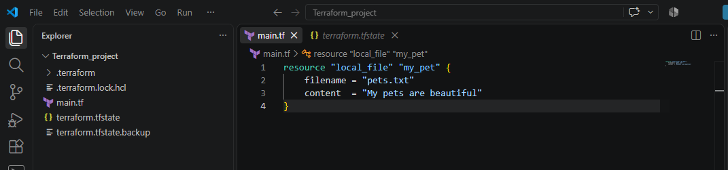

Step 2: Test Terraform locally
Before involving Jenkins, test the template.
Open the VS Code terminal: terraform init
Then: terraform validate
Then: terraform plan
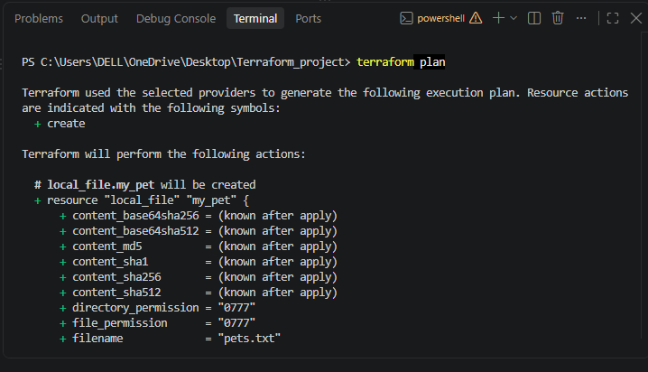

Step 3: Create a GitHub repository
Create a new GitHub repository, for example:
terraform-jenkins

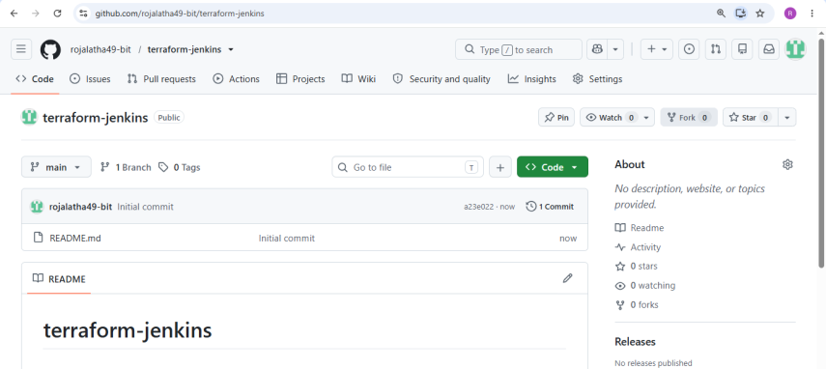
Push your main.tf:
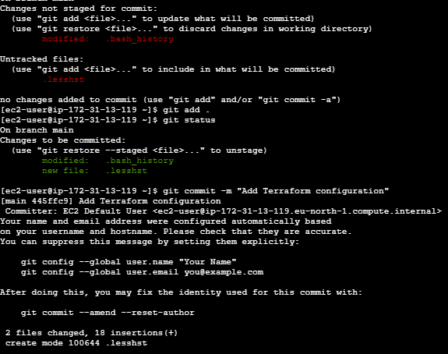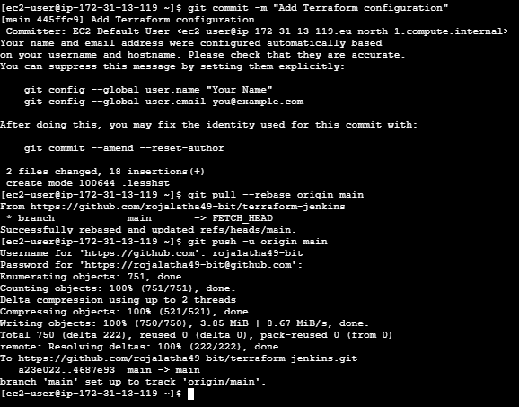
Step 4: Make sure Jenkins can access AWS
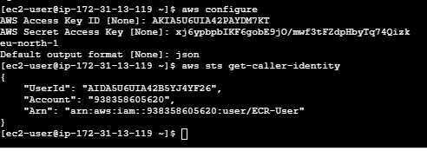

Verify Terraform can access AWS
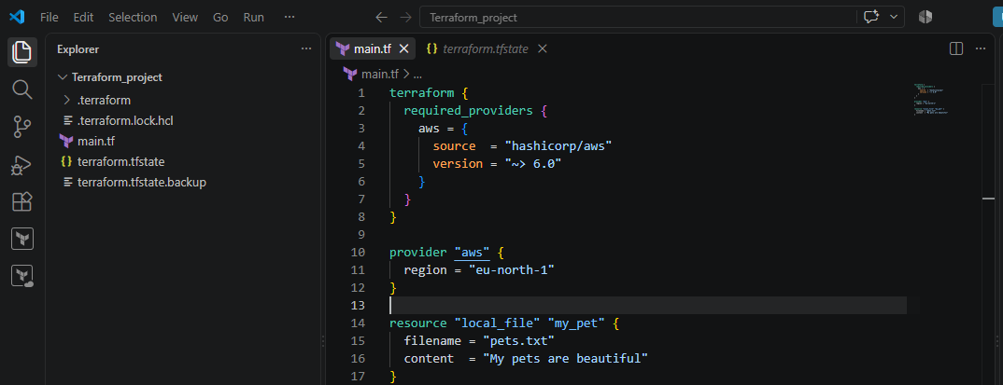
Initialize Terraform
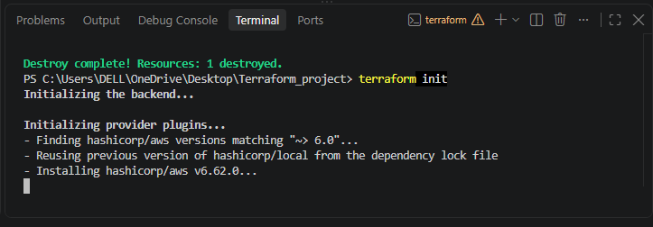
Terraform apply
